DAC619 AI for Games

# HTN Lab

1. 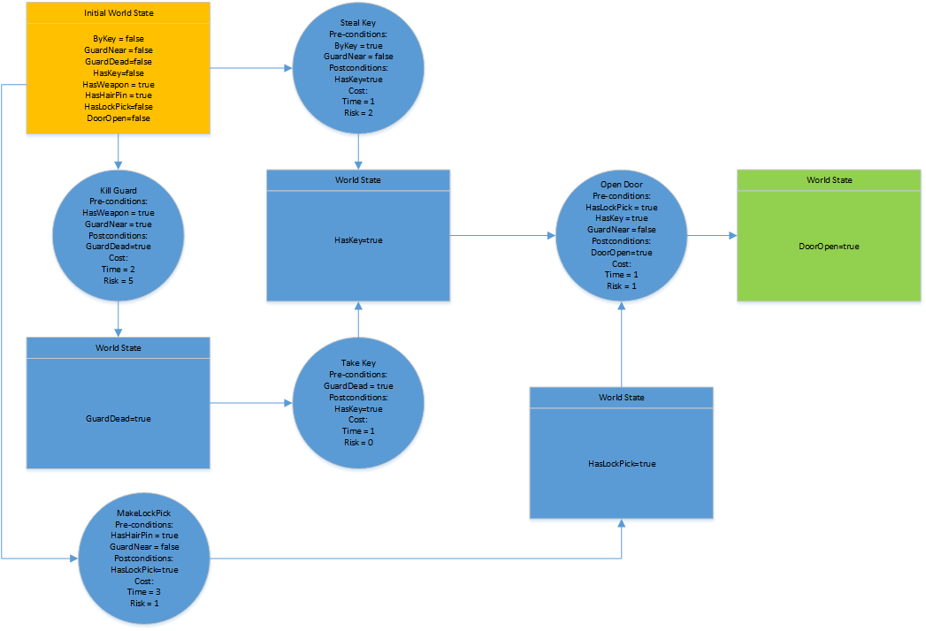Last week you were given a planning problem formatted for GOAP. The goal is to find a sequence of actions to open a door. The planning graph is given below. Convert the graph into a tree structure suitable for a Hierarchical Task Network.
2. Follow the tree by hand to develop the plan, feel free to change the starting conditions to experiment with different initial conditions.